Needs Assessment: Rutland Children with Special Educational Needs and Disabilities (SEND)

Version Control | Version 2.0
Document Owner / Authorising Officer | Head of Early Intervention, SEND and Inclusion
Target Audience | RCC Staff; Commissioners and Providers
Publication Date | September 2020
Review Date | April 2023

Contents Page

- Introduction Page: 3

- Background Page: 3

  - Definitions and scope

- Rutland’s Children and Young People Plan Page: 4

- National Context Pages: 4 - 5

- Understanding needs Pages: 5 - 7

5.1 Rutland demographics
5.2 Poverty and deprivation
5.3 Health of Rutland Children

- Children with SEND Pages: 8 - 11

6.1 Profile
6.2 EHCPs
6.3 Demand
6.4 Placements
6.5 Post 16
6.6 School Exclusions
6.7 Wider Services
6.8 Disability Register

- Meeting Statutory Timescales Page: 11

7.1 EHCNA
7.2 Health Assessments

- Performance of Rutland Schools Pages: 11 - 12

- SEND Expenditure Page: 12

- Voice of Children, Parents and Carers Pages: 12 - 13

10.1 Co-production
10.2 Capturing Voice
10.3 Personal Budgets

- Joint Commissioning Page: 13

- Gaps and Recommendations Page: 13-14

Introduction

This needs assessment sets out the level of potential and known numbers of children with Special Education Needs and Disabilities living in Rutland, and provides an overview of the needs of these children and young people and the services in place to support them.

Background

Children and young people with special educational needs and/or disabilities (SEND) are some of the county’s most vulnerable people, and the local authority and its partners have a duty to protect them, care for them, and help them thrive. We must understand their needs, both collectively and individually, so that we can plan services that support them to fulfil their potential, enjoy their lives, have high aspirations, achieve their best, become confident and resilient, and make a successful transition into adulthood. Therefore, achieving our vision within our SEND and Inclusion Strategy for children and young people with special educational needs and disabilities to lead healthy, independent, and safe lives.

2.1. Definitions and Scope

This needs assessment covers the current and future health and care needs of children and young people with special educational needs and/or disability (SEND) aged between 0-25 years as identified in the SEND Code of Practice, (2015). These are defined as:

Child or young person (0-25 years) with a learning difficulty or disability which calls for special educational or training provision at early years providers, maintained nursery schools, mainstream schools and mainstream post-16 institutions.

Child or young person (0-25 years) with a disability under the Equality Act 2010 i.e. ‘a physical or mental impairment which has a long-term and substantial adverse effect on their ability to carry out normal day-to-day activities’.

A child or young person has SEN if they have a learning difficulty or disability that means they need special educational provision or support to help them learn. This means they have a significantly greater difficulty in learning than most of their peers, or they are not able to use the universal provision available within their school because of their disability. The term ‘SEN’ applies across ages 0–25, although the term ‘learners with learning difficulties and disabilities’ (LLDD) is often used post 16 through to adult services.

Under the Equality Act 2010, a disability is defined as a physical or mental impairment which has a long-term and substantial adverse effect on their ability to carry out normal day-to-day activities. Children and young people with disabilities do not necessarily have SEN, but there is an overlap. Where a disabled child or young person requires special educational provision, they will also be covered by the SEN definition.

In the Code of Practice, SEND is categorised into the following broad areas of need:

Cognition and Learning  Moderate learning difficulty  Severe learning difficulty  Profound and multiple learning difficulty  Specific learning difficulty | Sensory and/or Physical Needs  Visual impairment  Hearing impairment  Multi-sensory impairment  Physical disability
Communication and Interaction  Speech, language and communication needs  Autistic spectrum disorder | Social, Emotional and Mental Health

Rutland’s Children and Young People’s Plan

The Rutland Children and Young People ‘s Partnership and its strategic Plan 2022 - 2025 sets out its aims for children and young people in Rutland:

- Every child lives in a happy and safe environment.
- Children who do become looked after, or are leaving our care, are supported to achieve the best emotional, physical and learning outcomes.
- Children experience an aspirational and inclusive education offer in their community.
- The emotional health and wellbeing of children in Rutland will be promoted.

The Children and Young Peoples Partnership has also identified a number of key priorities for Rutland which we will focus on during the first year of our strategy – 2022-2023. These priorities have been chosen because national research, local data on needs and feedback from partners, carers and children and young people has identified a pressing need to focus our energies on these particular areas. By doing so we anticipate that we can make a real difference to the lives of our children and families.

- Transition to adulthood
- Emotional Health and Wellbeing
- Children at risk of harm
- Tackling Domestic Abuse
- Tackling Domestic Abuse

National Context

Under the Children Act 2004 “a children’s services authority in England must have regard to the importance of parents and other persons caring for children in improving the well-being of children” (Section 10(3) of the Children Act 2004). The Children Act 2004 placed statutory duties on local agencies to make arrangements to safeguard and promote the welfare of children in the course of discharging their normal functions.

The Government’s statutory guidance Working Together to Safeguard Children (2010, revised 2018) made clear that safeguarding and promoting the welfare of children ‘depends on effective joint working between agencies and professionals that have different roles and expertise’. Working Together further clarifies the responsibilities of professionals towards safeguarding children and strengthens the focus away from processes and onto the needs of the child. Disabled children and young people are more likely to experience barriers to social participation, be at higher risk of violence and abuse and experience difficulties accessing key services and support.

The SEND Code of Practice 2015 is the statutory guidance for SEND used by local authorities, schools, and other providers. It is underpinned by the legislation set out in the Children and Families Act 2014. The Code of Practice is based on the following key principles:

- Participation: The views of children, young people and their families must be central to decision making, at both individual and strategic levels.
- Identification of needs: Early years providers, schools and colleges should identify needs and make provision as soon as possible. All local agencies must work together in Health and Wellbeing Boards to assess health needs of local people.
- Choice and control: Services should be evidence based, taking examples from best practice, and tailoring them to individual needs. Goals should focus on the child or young person’s strengths and capabilities and the outcomes they want to achieve.
- Collaboration: education, health and social care services must work together to assess local need and continually review SEND provision. Joint commissioning arrangements must be in place to support those with SEND, whether they have an EHCP.
- High quality provision: Schools and colleges should ensure provision of high-quality teaching with high ambitions and stretching targets.
- Inclusive practice: Removal of the barriers to learning and participation in mainstream education. No discrimination of disabled children for a reason related to their disability.
- Preparation for adulthood: Aspiration for successful long-term outcomes in adult life. Local agencies should work together to help children and young people realise their ambitions for higher education, employment, and independent living.

There is also the NICE guidance on transition from children to adult’s services for young people using health or social care services21 which is relevant for some young people with SEND. The overarching principles are that young people and their carers are involved in planning, co-production and evaluation of transition services, the support should be strengths-based and person-centred, education, health and social care should work together to plan for young people with transition support needs.

The SEND Code of Practice 2015 puts the views of children, young people, and their families at the heart of commissioning for SEND services.

5. Understanding Needs
The local authority has developed a comprehensive analysis of the profile of SEND learners from birth and has considered the availability and cost of provision currently, and the amount and type of future provision that will be needed and where this provision can best be situated. This analysis has been presented to the School’s Forum to engage schools with the issues that need to be addressed and give them ownership of the solutions.

5.1 Rutland demographics

The population of Rutland as at the 2021 mid-year estimate was 41,381 comprising 21,304 males and 20,077 females. There are an estimated 8,976 children and young people aged up to 19 years in Rutland, 1,637 of whom are aged 0 to 4 years, and 7,339 of whom are aged 5-19 years.

There is a particular spike in the population between the ages of 15 to 18, and this is especially pronounced for males. This runs contrary to the regional trend and might be because of the local independent boarding schools in Oakham and Uppingham. The next age banding of 19 to 24 years shows a significantly lower population that the previous age group and the regional picture, suggesting that young people are migrating away from Rutland post-school. With life expectancy set to increase it is anticipated that the population of older people within Rutland will increase significantly over the next 20-30 years, and at a greater rate than children and young people.

5.2 Poverty and deprivation

Rutland is one of the most affluent counties in England. According to the 2019 indices of deprivation (note – this is still the latest data at May 2023), Rutland is ranked 303 of 317 local authorities (with 1 being the most deprived, and 317 being the least deprived).

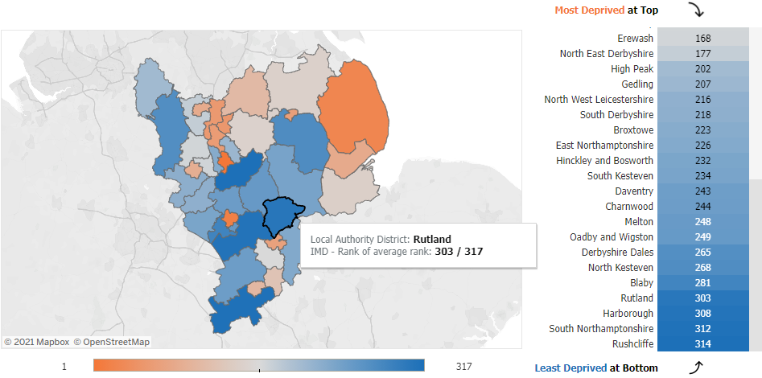
Figure 2: 2019 indices of deprivation, East Midlands map

As shown in figure 2 above, Rutland is the 4th least deprived local authority area in the East Midlands.

Being ranked 303 of 317 represents an improvement from the 2010 and 2015 indices, where Rutland was ranked 293 and 291 respectively.

5.3 Health of Rutland Children

Overall, comparing local indicators with England averages, the health and wellbeing of children in Rutland is better than England. The latest (published March 2023) Public Health England snapshot of Rutland child health shows:

The child population in this area
 |  | Rutland | Region | England
Live births (2021) |  | 274 | 47,860 | 595,948
Children aged 0 to 4 years (2021) |  | 1,600  4.0% | 251,600  5.2% | 3,058,200  5.4%
Children aged 0 to 19 years (2021) |  | 9,000  21.7% | 1,109,300  22.7% | 13,040,500  23.1%
Children aged 0 to 19 years in 2031 (projected from 2018) |  | 9,300  21.1% | 1,164,800  22.3% | 13,357,000  22.5%
School children from minority ethnic groups (2022) |  | 547  9.4% | 195,083  27.8% | 2,835,124  35.0%
School pupils with social, emotional and mental health needs (academic year ending 2022) |  | 147  2.5% | 20,861  2.9% | 250,272  3.0%
Children living in poverty (financial year ending 2021) |  | 8.5% | 16.1% | 18.5%
Life expectancy at birth (2018 to 2020) | Boys | 83.2 | 79.2 | 79.4
 | Girls | 85.0 | 82.7 | 83.1

Children aged under 16 years living in poverty
Map of the East Midlands region with Rutland outlined, showing the relative levels of children living in poverty in the financial year ending 2021, divided into national quartiles:

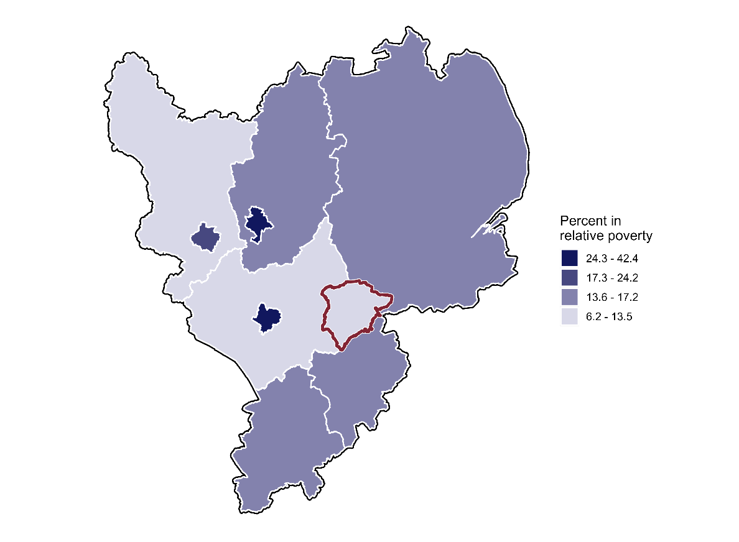

6. Children with Special Educational Needs and Disabilities

6.1 Profile of Children with SEND in Rutland schools

- There are total of 805 SEND students in Rutland Schools as at the Spring 2023 School Census

- The gender split for Children with SEND in Rutland schools is 66% male and 34% female.

- 54% of children with SEND are aged 0-11 years (primary) and 46% 12-17 years (secondary and Post 16).

- 723 (89.8%) of children with SEND are White British. The next biggest category is White Other (2.2%) then Mixed Other (1.6%). No other ethnic groups have more than 6 children. This is broadly reflective of Rutland’s population.

- 26 children with SEND (3.2%) do not speak English as a first language.

SEND Categories:

The table below shows the numbers of children attending Rutland schools by primary type of need compared to England figures.

State-funded primary, secondary and special schools: Number and percentage of pupils with special educational needs by primary type of need
Pupils with SEN with statements or EHC plan or on SEN Support
 | Rutland |  |  | England
 | Number |  | % | Number |  | %
Moderate Learning Difficulty | 169 |  | 23% | 229,446 |  | 17%
Speech, Language and Communications Needs | 94 |  | 13% | 319,757 |  | 23%
Social, Emotional and Mental Health | 147 |  | 20% | 258,441 |  | 19%
Specific Learning Difficulty | 139 |  | 19% | 163,031 |  | 12%
Other Difficulty/Disability | 16 |  | 2% | 53,144 |  | 4%
Autistic Spectrum Disorder | 76 |  | 10% | 182,493 |  | 13%
Physical Disability | 12 |  | 2% | 36,882 |  | 3%
Hearing Impairment | 9 |  | 1% | 22,884 |  | 2%
Visual Impairment | 8 |  | 1% | 13,596 |  | 1%
Severe Learning Difficulty | 5 |  | 1% | 33,938 |  | 2%
Multi- Sensory Impairment | 3 |  | 0% | 4,112 |  | 0%
Profound & Multiple Learning Difficulty | 0 |  | 0% | 10,877 |  | 1%
 |  |  |  |  |  | 0%
SEN support but no specialist assessment of type of need (9) | 57 |  | 8% | 46,103 |  | 3%
Missing |  |  |  | 21 |  | 0%
Total | 735 | 100% |  | 1,374,725 | 100%
Source: Department for Education National Statistics January 2022

Spring Census 2023
 | EHCP | SEN Support | Total
SEND in Rutland Schools | 176 | 629 | 805
Total SEND with Pupil Premium * | 68 | 229 | 297
Of above SEND with FSM | 37 | 135 | 172

* Source Pupil Premium file March 2023

- As of the spring school census 2023 13.2% (805 children) of the school population have identified SEND.

- Of those with SEND 36.9% were in receipt of Pupil Premium (297 children).

- Of all children with SEND 17% (172) are in receipt of free school meals. This represents a higher percentage of children with SEND receiving FSM than children without SEND, which averages 10.3%.

6.2 Children with Education, Health and Care Plans (EHCPs)

Schools in Rutland have a lower proportion of pupils with EHCP’s compared to the average for England in 2022 at 4%. Rutland as at Spring Census 2023 2.9% (n = 176) and 2.8% in 2021. This has increased gradually over the past 5 years, having previously reduced from 265 (3.5%) in 2015.

Rutland has a slightly lower proportion of pupils with SEN Support: 10.3% (n = 629) compared to 12.6% for England overall. Whilst this has remained broadly similar for England, it has fluctuated locally from 8.5% in 2015 (n = 653), to 11.5% in 2016 (n = 901) and then a high of 13.1% in 2018 (n= 1011) this number decreased in 2020 n = (636) to 10.9%.

Data for individual schools is not broken down within this document as it may result in individuals becoming identifiable. The local authority does hold this data internally.

6.3 EHCP Demand

The overall volume of children who are resident in Rutland and have an EHCP has increased significantly over the past 3 years, by over 60%, transitions across phases of education continues to drive numbers of EHCPs.

Schools report this is often because of differing levels of support available and the impact of additional curriculum challenges.

Since January 2019, the number of EHCPs maintained by Rutland County Council has increased from 198 to 305 as of April 2023. The number of EHCNAs requests had been increasing year on year to 62 in 2019, but with the pandemic impact slowed to 53 in 2021 and 52 in 2022. Year to date in 2023 there have been 34 requests for assessment which is higher than usual for the time of year.

The highest volumes of presenting needs for children with EHCPs in Rutland as of April 2023 are:
Presenting need | % of cohort
ASD | 32.8%
Social, Emotional & Mental Health Social Difficulties (SEMH) | 20.7%
MLD | 18.0%
Speech Language and Communication Need (SLCN) | 7.2%
Figures for other SEN are known but are compressed due to the low number.

6.4 School Placements

54 children with an EHCP living in Rutland attended an out of county special school as of end December 2021, this number has increased to 67 at the end of 2022. The overall high proportion in out of county special schools is, in part, due to the increasing numbers of children with EHCPs overall and the limited provision available within Rutland to meet needs.

There are a further 50 children with an EHCP attending a maintained designated special provision or Enhanced Resourced Provision within a mainstream school. It should be noted however that given the physical size of the county, the majority of those out of county placements are still within bordering counties, and thus travel is no more significant than it would be for a larger geographical county.

The numbers relating to pupils on roll in Rutland schools and therefore the number of children receiving SEN support or who have a EHC Plan will be different to the number of children who Rutland are responsible for, due to the number who attend out of county schools or specialist provisions.

The table below shows the numbers (and percentage) of children at Rutland schools split by their place of residence: in Rutland or out of county. This shows that almost half of the children with SEN support in Rutland secondary schools live out of county. For this cohort of 121 (out of county children with SEN Support, at secondary schools). Those attending Rutland schools and living outside the county, in the main live in the Stamford area, followed by villages in Leicestershire and Northamptonshire which border Rutland.

 | Primary Schools |  | Secondary Schools
 | Rutland  Children | Out of County  Children | Rutland  Children | Out of County  Children
Statement / EHCP | 79 (87.8%) | 11 (12.2%) | 63 (73.3%) | 23 (26.7%)
SEN Support | 302 (87.3%) | 44 (12.7%) | 145 (51.2%) | 138 (48.8%)

6.5 Post 16

At December 2022 there are 93 young people and adults with an EHCP aged 16-25. The vast majority of them are supported to go on to further education or employment. Of those post 16 with an EHCP 85 (91%) are in post 16 college or alternative provisions and the remaining in apprenticeships or residential provision.

6.6 School Exclusions

For the 2021/2022 academic year 51 children SEND with had a fixed term exclusion from school, 1 of which went on to be permanently excluded from school. A Further 3 children with SEND were also permanently excluded from school. It is very difficult to compare exclusions data for the last 3 years as the time in school was impacted on Covid.

6.7 Wider Services
April 22-March 23
86 children and young people have accessed Aiming High positive activities.
41 children and young people have accessed the Aiming High Short Breaks Scheme providing short break grants - of those 29 have an EHCP.

In total 107 SEND children and young people have accessed Aiming High support with 20 having accessed positive activities and were also in receipt of the Short Breaks Scheme.
104 parent/carers accessed support, information and advice on ADHD and/or ASD

6.8 Disability Register
March 23
Aiming High / Disability Register | Total | Number of children and young people who have EHCP
0-18 | 263 | 139
19-25 | 86 | 17
Out of area – all ages | 19 | 0
TOTAL | 368 | 156

Meeting Statutory Assessment Timescales

7.1 Education, Health and Care Needs Assessments (EHCNA)

There are national statutory timescales for assessing whether a child meets the requirement for an EHCP. Rutland has improved in meeting these and is now above both regional and national averages, despite a significant increase in requests since 2019.

EHCNA Statutory Assessment Timescales | 2021 | 2022 | 2023 YTD
No of EHCNA requests | 55 | 58 | 27
% decision within 6 weeks | 67/68 99% | 54/56 96% | 28/28 100%
% undertaken completed within 20 weeks | 15/36 42% | 33/50 32% | 3/5 60%
% Annual Reviews completed in timescale (academic year) | 89% | 81% | 82%
% Educational Psychology Assessments in timescale

  - Health Assessments

There remain lengthy waiting times for some services in particular Child and Adolescent Mental Health Services (CAMHS) and Community Pediatricians. It is understood that a recovery plan is already in place for the Community Pediatric service. The care navigator and dedicated clinical officer roles within health add value and the next step could be to utilise the role to collate and feedback issues with access to health services and the impact on children.

Performance of health assessments for CYP with LD – 80%

- Performance of Rutland schools in meeting the needs of SEND pupils.

- Educational achievement in Rutland schools for children with an EHCP or identified as receiving SEN support strong and is generally at or above average, though it must be recognised that in some cases small numbers can mean that percentage comparisons need to be treated with caution.
- As an outcome of the impact of the pandemic on 2020/2021 and 2021/22 school performance data, the DfE recommends not making direct comparisons with data from previous years.
Early Years Foundation Stage:
- 31.6% of children identified with SEN Support achieved a good level of development in 2022 compared with 23% nationally.
- 33% of children with an EHCP achieved a good level of development in 2022 compared with 3.7% nationally, however there were only 6 children in this cohort which must be taken into account when comparing percentages.
Key Stage 1:
- 29.3% of children identified with SEN Support achieved expected levels in 2022 compared with 29.6% nationally in reading, 22.0% in writing compared with 19.6% nationally, and 43.9% in maths compared with 33.1% nationally.
- 14.3% of children with an EHCP achieved expected levels in 2022 compared with 12.1% nationally in reading, 14.3% in writing compared with 7.3% nationally, and 28.6% in maths compared with 13,8% nationally.
Key Stage 2:
- 19.0% of children identified with SEN Support attained expected levels in combined reading, writing and mathematics compared with 21.0% nationally, however there were only 47 children in the Rutland cohort, with each child equivalent to 2% so this would be broadly in line with national.
- 4.0% of with an EHCP attained expected levels in combined reading, writing and mathematics compared with 7% nationally, however there were only 23 children in the Rutland cohort, with each child equivalent to just over 4% so, again, this would be broadly in line with national.
- Children identified with SEND Support and with an EHCP made good progress from Key Stage 1 in Rutland schools in all areas other than for children with SEN Support in mathematics.
Key Stage 4:
- Attainment 8 was achieved by 43.3% of children identified with SEN Support compared with 34.8% nationally.
- Attainment 8 was achieved by 28.7% of children with an EHCP compared with 14.3% nationally.
- Progress 8 scores for children with SEN Support and an EHCP were well above national levels:
- 0.21 compared with -0.47 for SEN Support and -0.17 compared with -1.33 nationally for children with an EHCP.
- During the academic year 2021 – 2022, no child looked after (CLA) with an EHCP was excluded from education.
- 2 CLA with an EHCP were eligible for end of KS4 exams in summer 2022; 1 achieved functional skills, and 1 will be taking re-sits this summer because they did not achieve level 4 in English and mathematics.
- In the primary sector, 1 eligible CLA with an EHCP was eligible for SATs in summer 2022. This child did not reach the age-related level in KS1 SATs; PEP meetings focus on interventions to accelerate learning and this child will be attending to independent special school from September.
- The other 4 CLA with EHCPs continued to make expected progress in their academic learning which is regularly reviewed within the PEP process.

SEND Expenditure against SEND needs

The demand for, and the spending on services and support for children with SEND in Rutland has grown significantly. The total number of pupils with SEND (EHCPs and SEN support), based on where the pupil attends school, was 805 in Spring 2023. This represents 13.8% of the total number of pupils in all Rutland schools, comparable with the England benchmark (2022 figures) of 16.6%.

The expenditure for high level SEND support in Rutland has increased significantly since 2019/20 to meet increased demand. The expenditure has risen from £4.1m in 2019/20 to £5.4m in 2022/23 which equates to an increase in excessive of 30%.
A high proportion (20%) of children with EHCPs are placed in out of County special provisions which is driving overall expenditure. Where children are placed out of county in specialist schools, comparative regional fee levels and detailed cost breakdowns are used to understand each aspect of school spend and to achieve value for money.
The average costs of placements are similar to national figures. Rutland’s most expensive placements being those for children with Social, Emotional & Mental Health Social Difficulties. There are some differences in the funding of top-ups in different settings when compared to national figures, but these reflect what we need to commission within Rutland.

The Voice of Children and their Parent and Carers

10.1 Co-producing with families.

The service works closely with Rutland Parent Carer Voice (RPCV), Sunflowers group and Disabled Young People Forum (DYF) to routinely ascertain views and to understand what life is like for them and use this to adapt the services we offer. This has included consultation and co-production exercises on our Local Offer website, capital investment, staff recruitment, contract specification and development of information materials. Both RPCV and RDYF have been consulted regarding several service changes during Covid 19 e.g. development of online sessions for children and young people and parent/carers, additional flexibility of the Aiming High short beaks scheme.

Children and young people continue to take the lead on planning activities and sessions for all Aiming High positive activities.

Parents are represented on our Children and Young People’s Partnership and Corporate Parent Board which offers the opportunity for parents to influence services at both a strategic and individual level. RPCV are included in training to help build their infrastructure as the key parental voice, strengthening relationships and building shared ownership of the agenda and service delivery in Rutland. Senior leaders regularly join the RDYF to ensure an understanding of what life is like for them at a senior level.

Capturing Voice

We have enhanced the quality of our EHCNAs by increasing the involvement of children, parents and carers in the assessment process through the introduction of ‘Getting to Know You’ meetings which complement the ‘my story’, our story’ forms helping to ensure the assessment process accurately captures the wishes, feelings and needs of the child. This culminates in a plan setting meeting which supports the coproduction of plans.

We ensure that the voice of the child, parents and carers remain at the centre of the whole decision-making process, with conversations and interactions with the child or young person and parents being cited by the case officers at the SEN panel where final decisions are made.

We have developed ‘My Plans for the Future’ to support children and young people to inform the design of their plan and support their transition into adulthood.

Practitioners utilise Signs of Safety which is a solution focussed tool designed to capture the wishes and feelings of children and parents and the approach has been incorporated into our assessment mechanisms across Early Intervention and Children’s Social Care to enable services to better understand views, from the perspective of children and parents/carers, which subsequently helps children and families to own their plan.

Annual reviews provide opportunities for parents, carers and children to share their views into a revised position statement of the child’s needs and progress, this includes survey monkey to capture feedback on the support offered from both parents and children.
Health services utilise the Friends and Family questionnaire and captures feedback to inform delivery.

Independent Advice and Support: SENDIASS provide support and advocacy for families and the service is actively promoted through the Local Offer, RPCV, DYF, Family Drop-ins, Sunflowers and SENCO network etc. The service provides one to one support, which can include attendance at Team Around the Family (TAFs), Annual Reviews and other meetings to enable the voice of children and parents to be heard. To facilitate access, the service provides an array of access channels including face to face drop in, website and phone.

As part of this offer, SENDIASS now have dedicated capacity to support children and young people which is focussed on those cohorts where changes are taking place eg during Y6, Y9 and Y11 transition points. The dedicated capacity was developed in conjunction with the Rutland Disabled Youth Forum – support can be on a 1:1 basis either prior to, during or post an annual review and also covers group work with cohorts of young people with SEND in Rutland secondary schools. The aim is to ensure that young people know they have a right to express their views, they have the confidence to share these and are supported to do so in a format of their choice.

We have an advocacy service provided by Age UK in place for children aged 14 and above which provides additional support with a focus on transitions into adulthood and appropriate service support. We have trained frontline staff to deliver advocacy support through our services for young people and subsequently children who are in the social care system including children looked after or care leavers, have the option of independent advocacy to support them and enable their voice to be heard within the process.

10.3 Personal Budgets

There remains a need to ensure parents understand their personal budget and how they can use this to meet social care needs as usage of personal budgets is still low. However, parents utilise their direct payments to access short breaks support successfully.
The local authority holds data on families known to Adult Social Care but given the low numbers this is not provided here.

Joint Commissioning with Health

In Rutland there is a multi-agency advisory panel/decision making process which discuss support and provision with children and young people with SEND. Our advisory panel brings agencies together to discuss complex cases and to assess the suitability of EHCNA, EHCPs, education placements and additional funding requirements, ensuring these are the most appropriate for a child’s need. The SEND panel supports the co-ordination of assessment information and ensures the commissioning of services is effective and that the level of resources provided is owned and directed by partner agencies. The panel is responsible for the allocation of High Needs Funding (Designated Schools Grant) to children who have an EHCP and reviews complex cases providing clarity on responsibilities for provision and funding e.g. Education, Social Care and Continuing Health Care funding arrangements.

Rutland is an active participant in the LLR SEND Joint Commissioning Strategic group, with other local authorities, ICB and LPT representatives, and parents, which sets out key priorities which require and are supported by a whole system approach.

Gaps and Recommendations

- Progress our SEND Commissioning Strategy in response to the joint work currently underway across LLR and the region, to identify need and demand and to respond by providing good quality and sufficient education and care provision.

- Complete the review of our early years and primary inclusion pathway to ensure children are identified early and providers have the capacity and expertise to support children in mainstream provision.

- Our Delivering Better Value transformation will improve our data collection and business intelligence so that we capture how SEND needs change over time which will inform our commissioning intentions and use of our High Needs Fund.

- Work with our partners, especially Health and with our providers to respond to the needs of children with ASD and social and emotional and mental health difficulties. To engage the ICB and health providers in driving forward the new SEND provision in Rutland, to ensure there is multi-agency support and that implications for local health services can be planned and managed.

- The SEND service and partners engage fully in the participation and engagement strategy to hear the voices of children and young people with SEND and their families. To have in place mechanisms to gather and utilise their feedback, to understand what works for them and which informs service planning and design.

