Location Plan

A location plan is needed so that the location of the application is clear.
The Location Plan must consist of the following: | Tick or N/A
To a scale (1:1250/1:2500)

Direction of North

Proposed development to scale

Proposed development clearly outlined in red

Other land in ownership outlined in blue

This should be based on an up-to-date map and the scale should typically be 1:1250 or 1:2500. The location plan should identify sufficient roads and/or buildings on land adjoining the application site to ensure that the exact location of the application site is clear. The application site should be outlined clearly with a red line, with any other land in your ownership (if applicable) outlined in blue. The plan must also show the direction of north.
A Location Plan can be purchased from one of the planning portal's accredited suppliers, and there is also guidance to show what this plan should look like - please see website here: https://www.planningportal.co.uk
Good Example of Location Plan
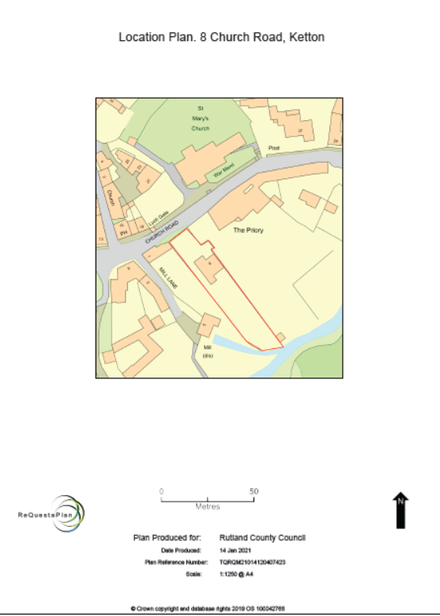

Unacceptable Example of Location Plan
